By: M.Sc. RAWNAQ THAMER Kadeem

Organic CHEMISTRY
FIRST LEVEL
Secound semester 1444 - 1445
2023 - 2024

[Type the document subtitle]
DR.Ahmed Saker 2o1O

Experiment (2)
Determination of Boiling point for organic compounds

INTRODUCTION:-
Boiling point is the temperature at which the vapor pressure of a liquid is exactly equal to the atmospheric pressure(101 kPa or 760 mmHg or 760 torr exerted on it, causing the liquid to "boil" or turn into the gas phase. The boiling point of an organic liquid is the temperature range over which the state of an organic compound changes from the liquid phase to the gaseous phase at a pressure of 760 mmHg.
The molecules of compounds in the liquid state are relatively close to each other, compared to the molecules of gaseous compounds. This close proximity between molecules in the liquid state allows them to bond with each other through non-covalent bonds (H-bond, van der Waals forces). In general, these interactions help hold molecules together in a specific volume, but still allow for free movement or “flow.” Conversely, the molecules of a gaseous compound are much farther apart from each other and are not confined to a specific size by non-covalent interactions Fig. )1).
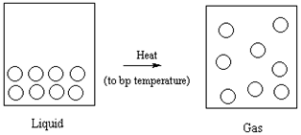
Fig.)1(: Phase Change from Liquid to Gas at Boiling Point Temperature Range

THEORY:-
The boiling point of a compound is the temperature at which it changes from a liquid to a gas. If enough energy (often in the form of heat) is provided to the liquid, the molecules begin to move away from each other by "breaking" non-covalent forces that exist in the compound in the liquid state. This is a physical property often used to identify substances or to check the purity of the compound.

The Materials:-
- Hot plate.
- Closed end capillary tube.
- Thermometer.
- Liquid organic compounds
- Small test tube.
- Beaker (250 ml).

Purpose:
- To become acquainted with procedure in evaluating physical properties such as boiling point.
- To determine the boiling points of organic compounds and to use these to identify unknowns.

Procedure :-
- A small amount (≈ 2 ml) of liquid is placed in a small test tube.
- Then a capillary tube is placed, closed at one end, upside down (the open side is immersed in the liquid) Figure (2).
- The assembly is firmly attached to the thermometer using a rubber band, and the entire assembly is mounted on a ring stand Figure (3).
- Immerse the assembly in an oil bath for samples Figure (4). As the temperature slowly increases, rapid development of bubbles begins at the end of the tube. Continue heating for approximately 5-10 seconds to ensure that all the air is expelled from the capillary, and that the liquid vapors remain in the capillary.
- Watch the capillary tube carefully, as you will notice bubbles appearing continuously until the pressure resulting from the liquid vapor becomes equal to the atmospheric pressure.
- Read the thermometer and record the temperature. )The temperature observed when this occurs should be the observed boiling point of the liquid(
- Compare your experimental results with the literature value (table below) for the boiling point of the liquid used. If your technique is good, the experimental value should not differ from the known value (literary value) by more than 2-3°C.
- Repeat the procedure with known liquids. Each time you do this procedure, you must use new capillary tubes. It will also be necessary to allow the hot bath to cool to at least 15 to 20°C below the suspected boiling point before repeating your experiment.
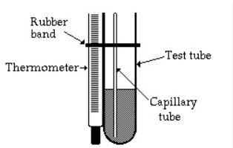
Fig. )2( - Small test tube and capillary, sealed at one end

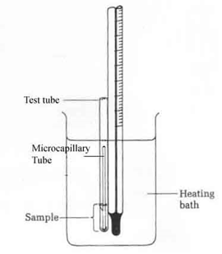
Fig. )3(- Small Scale Boiling Point Apparatus

Fig. 4 - Boiling Point Apparatus Set

Substance | Boiling Point (ºC)
Pentane | 36.1
Hexane | 69
Heptane | 98.4
Octane | 125.7
2-Methylheptane | 117.7
3-Methylheptane | 119
2,2-Dimethylhexane | 106.8
3-Ethylpentane | 93.5
2,2,4-Trimethylpentane | 99.2
Acetone | 56- 57
Methanol | 65
Ethanol | 78-79
Propanol | 97-98
2-Propanol(isopropanol) | 82-83
Water | 100
t-Butyl alcohol | 83
Cyclohexane | 80.7
Methylene chloride | 111
Bromoform | 146-150

Factors Influencing Boiling Point
Structural features of a compound influence the boiling point by increasing or decreasing the molecules' ability to establish and maintain non-covalent interactions that hold the molecules close together in the liquid state. The structural features of a compound that influence boiling point are:
- Polarity - Increased H-bonds, polar covalent bonds or formal charges in a molecule tend to increase the boiling point. More polar elements in a molecule increase the total number of dipole-dipole, ion-dipole and/or H-bonding interactions. More energy (higher boiling point temperature) is necessary to break these interactions and allow the molecules to move away from each other into a gaseous state.
- Molecular Weight: Increased molecular weight increases boiling point A higher molecular weight compound has more atoms that can be involved in non-covalent interactions. The greater the number of non-covalent interactions, the more energy (higher boiling point temperature) that is necessary to break the non-covalent interactions to transform the compound from the liquid phase to the gas phase.
- Branching: Branching decreases boiling point. Branching blocks molecules from packing together too closely. The closer molecules are, the stronger the non-covalent interactions. Thus, molecules that are forced to be farther away from each other due to branching have weaker non-covalent interactions. Less energy (lower temperatures) is needed to induce a phase change from the liquid phase to the gas for branched compounds relative to straight chain compounds. (Fig. below):

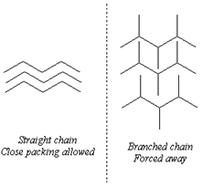

Home work:-
Q1/: Which of the compounds, ethanol, C2H6O, or methanol, CH3OH, should have the higher boiling point?
Why?
Q2/: What is the effect of small amount of impurity on the boiling point of an organic compound?
Q3/: What is the effect of small amount of impurity on the boiling point of an organic compound?

